CbTSP configuration files

Quick Guide

Summary

Introduction 2

GeoJson File 2

PBF File 3

Extracting GeoJson boundaries 4

Extracting Geographical Data (PBF) 7

Defining the area of interest 7

Extracting the data – Local procedure 9

# Introduction

CbTSP installation and operation have been designed to be as hassle free as possible, there are some variables though that need some attention, and that depends on the specific deployment site, the instance is related to.

There are 2 objects that need to be specified and built specifically for every demo site and those objects are:

1. An object which describes the “area of influence” of the instance (GeoJson)
2. An object with actual geographical, and administrative data (OpenStreetMap PBF file format)

# GeoJson File

* Should describe the borders of the area of influence
* It can be as granular as describing the whole administrative borders of an area of interest or as simple as a rectangular
* IT HAS TO BE HANDLED TO THE CFM’S

**Examples:**

This is an acceptable GeoJson definition

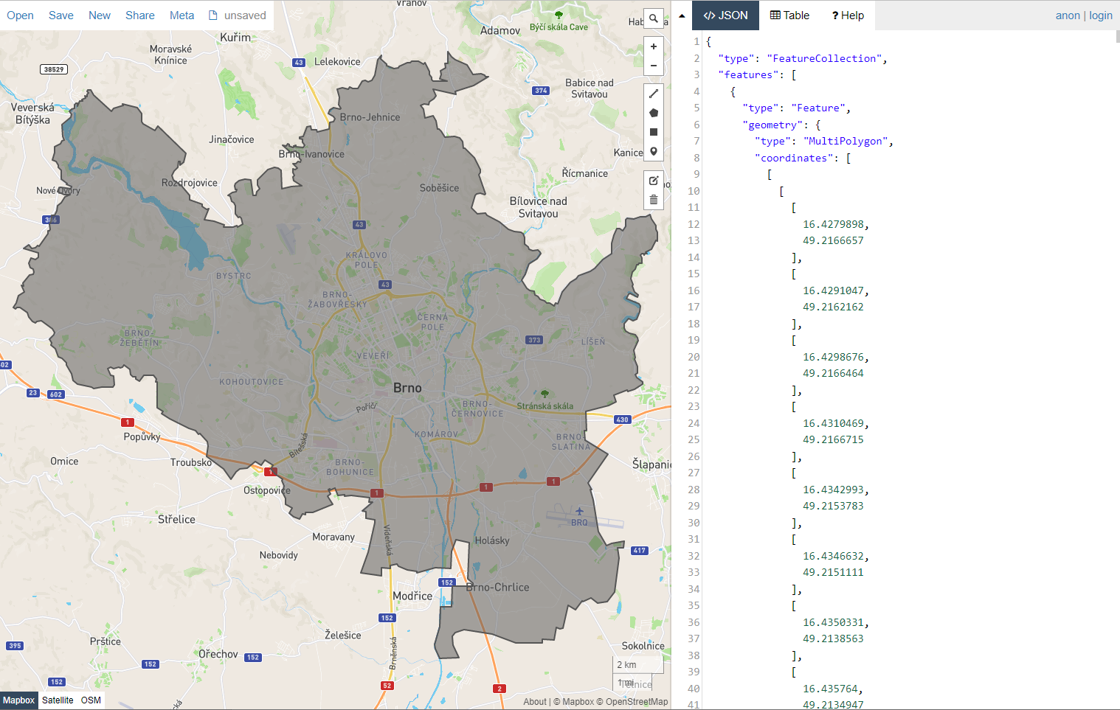

…But also this is a perfectly fine GeoJson definition:

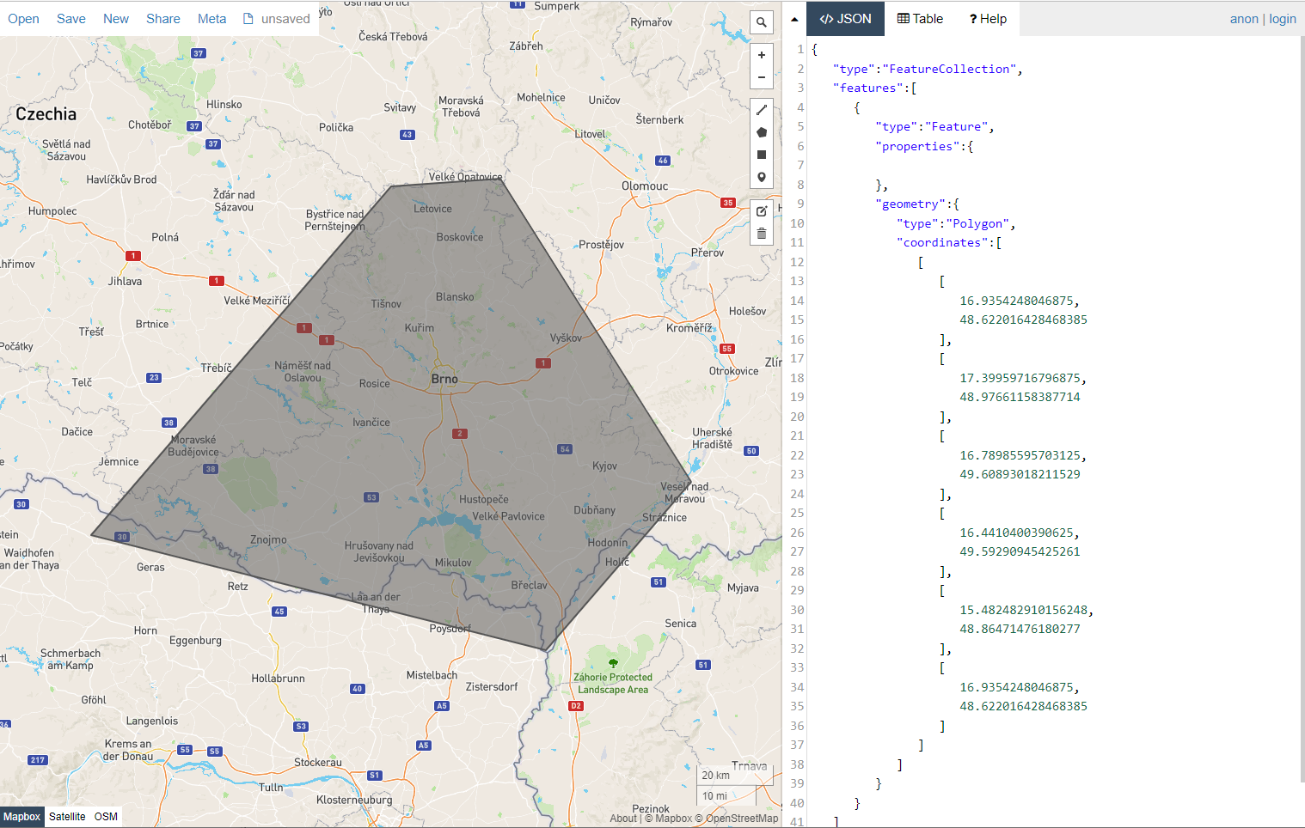

# PBF File

* Should be extracted from official OpenStretMap map objects
* **It need to cover at least** the same area described in the GeoJson (but slightly bigger is preferable)
* **It should not be absolutely huge** (i.e. if a small region is needed, you should be tempted to download, for example, the whole state that region is included to, this would dramatically impact on performance and would require a lot of more CPU power and memory than the one that are assigned to the machines designed for the demo sites, leading to unpredictable behaviour)

**Examples:**

Those in RED are correct PBF map boundaries with respect to the “area of influence” defined by the GREYED area of the GeoJson

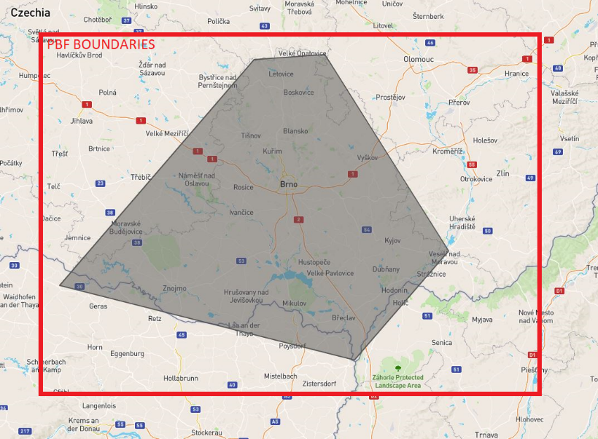

Those in RED **ARE NOT CORRECT** PBF map boundaries with respect to the “area of influence” defined by the GREYED area of the GeoJson

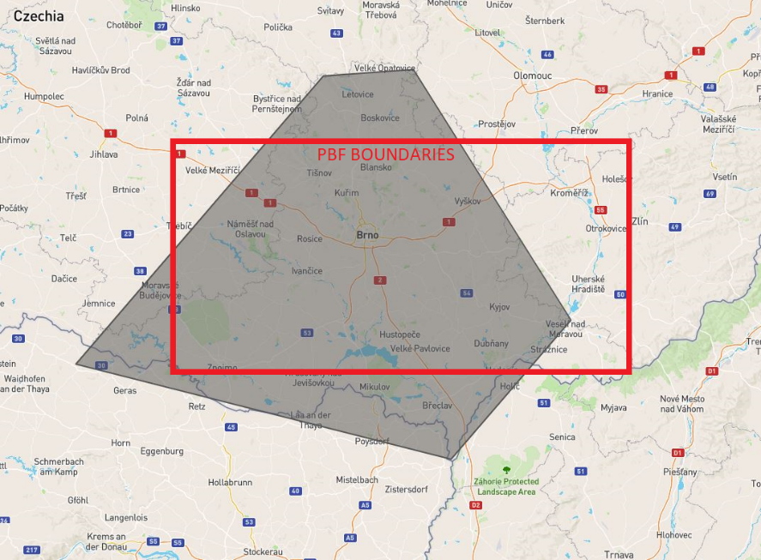

# Extracting GeoJson boundaries

Prerequisites:

* An active account on <https://www.openstreetmap.org/>

Notes:

* The site we are suggesting, is sometimes slow and has some little bugs, the execution presentet below is the one that should grant you a successful extraction
* If the page hangs, just wait for the webapp to resume execution (even if the browser warns you about that)

Execution:

1. Visit <https://osm-boundaries.com/Map> and Register/login (it should ask you to login with your OpenStreetMap account)
2. Select the State you are interested to (i.e. Czech Republic)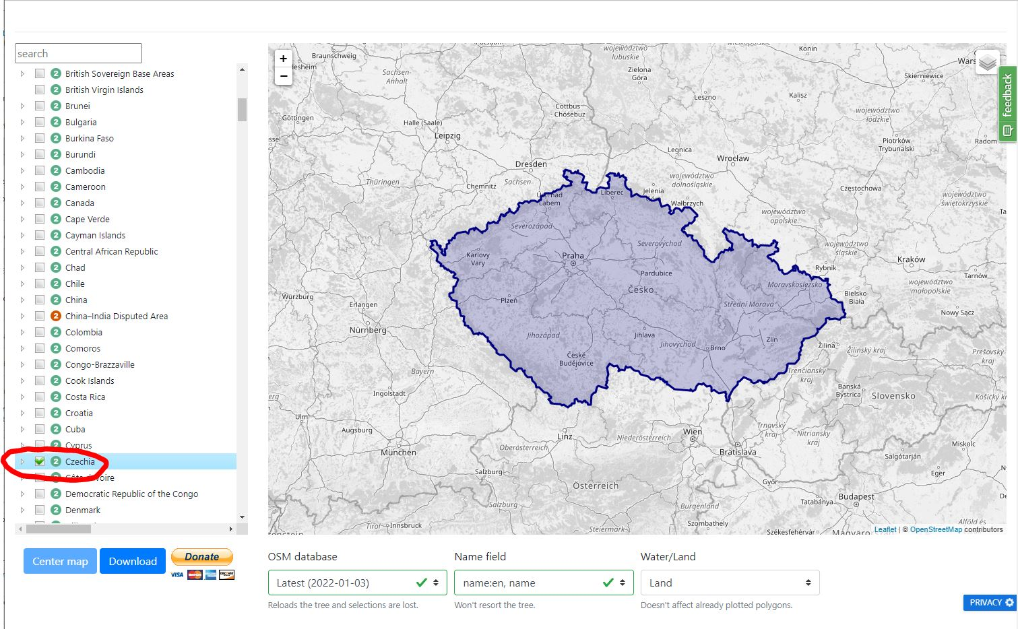
3. Then proceed selecting the region first, and then the local area of interest (i.e Brno) 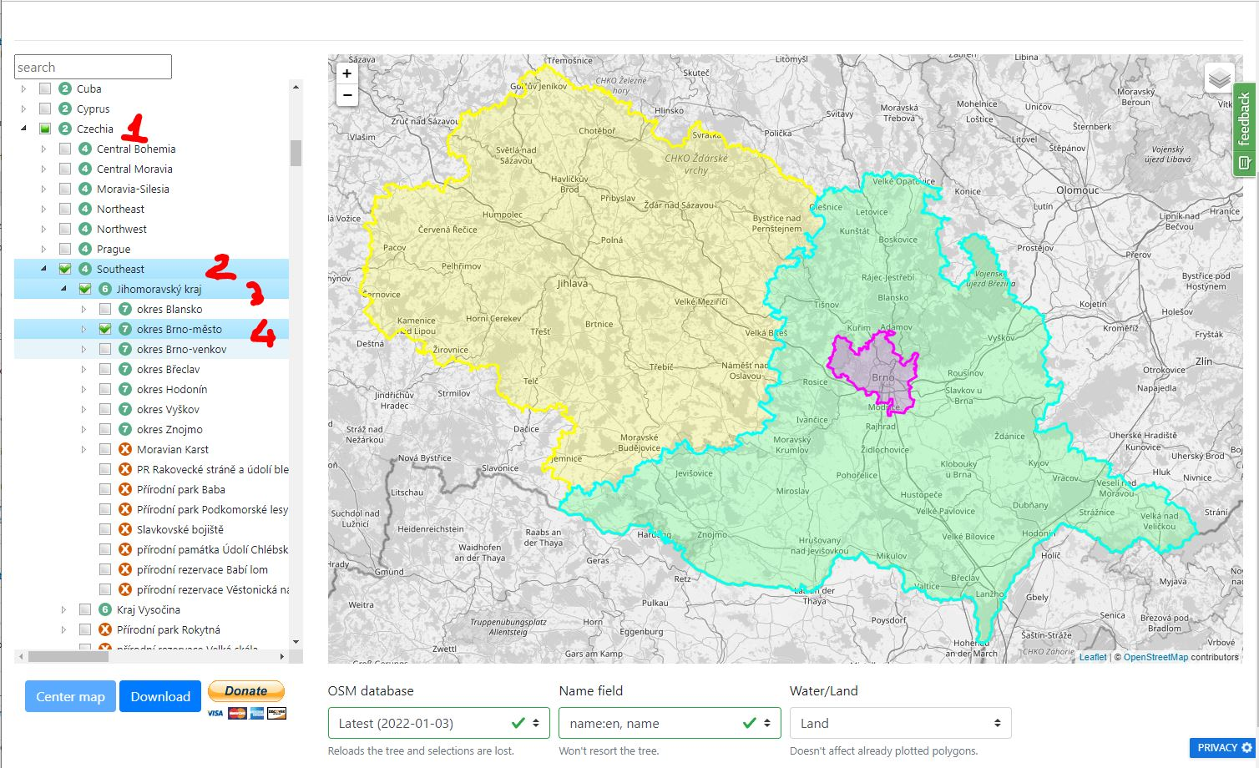
4. Finally deselect the outer boundaries and leave selected only the most specific one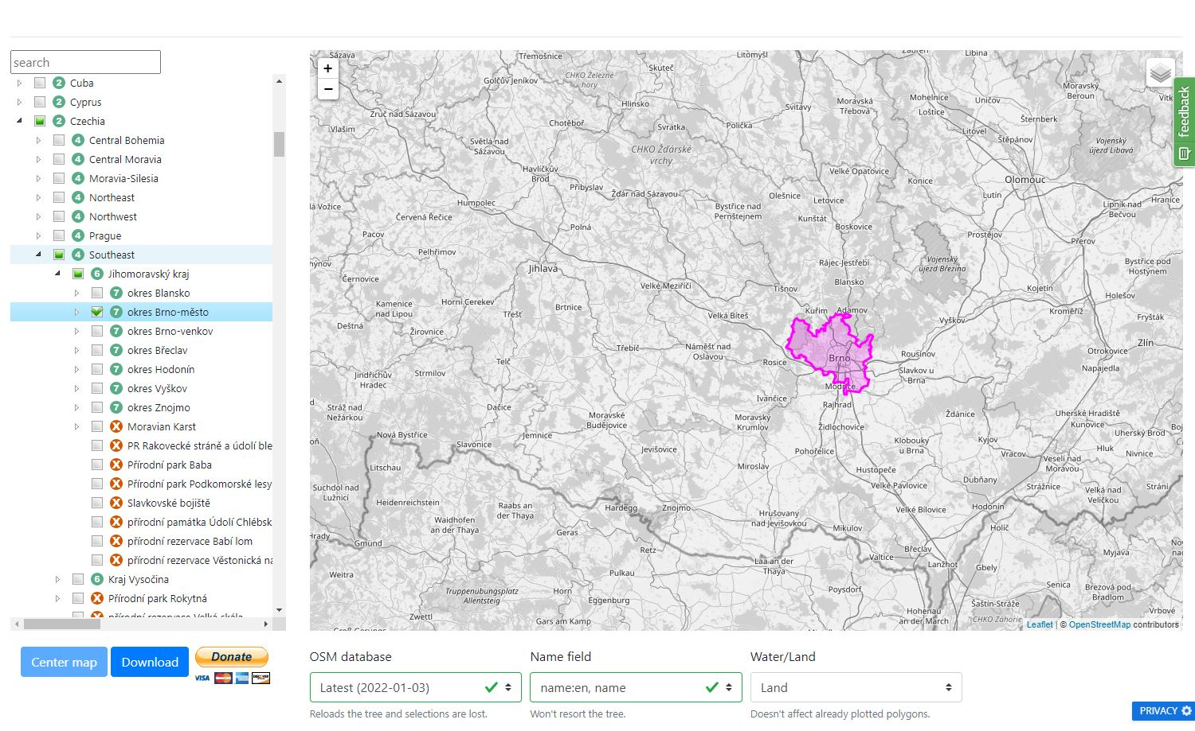
5. Once the area definition process is complete you can press the “Download” button, you should configure the requested parameters as shown in the image below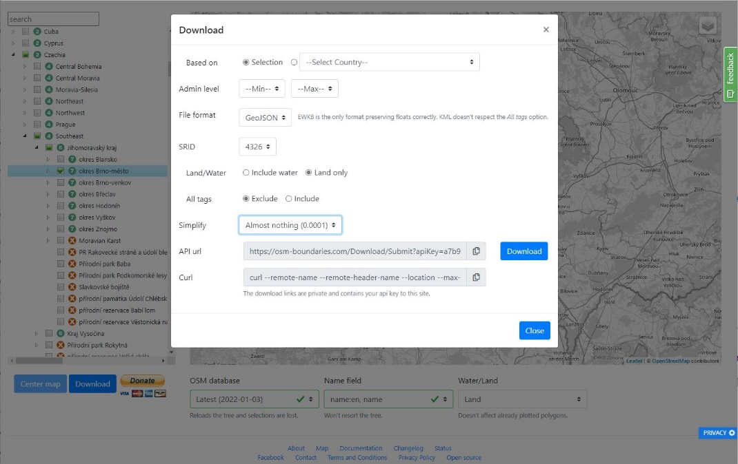

* Based on: selection
* Admin level: Min Max
* File format: GeoJSON
* SRID: 4326
* Land/Water: Land only
* All tags: exclude
* Simplify: This depends on how big the area is, the more you simplify, the more the shape gets approximated, usually, nothing or almost nothing is the way to go, unless you get a whole lot of coordinates points (and the GeoJson beomes as bigs as several megabytes)

1. You can now press the Download button on that modal window (the one in the center right of the image above)

# Extracting Geographical Data (PBF)

This process describes the steps to accomplish coordinate definition of the area of interest, that should be then used to extract a subset of the geographical data from the objects in the OpenStreetMap project, we will show a couple of methods of extraction but for more informations about various software you may want to try, and further methods, you can visit

https://wiki.openstreetmap.org/wiki/Main_Page

## Defining the area of interest

The simplest way to determine the sets of coordinates of your interest, is to take advantage of the OpenStreetMap site.

**Execution:**

1. Visit <https://www.openstreetmap.org/> and search for your city or region, then adjust the zoom level according to your preference and click on the export button on the top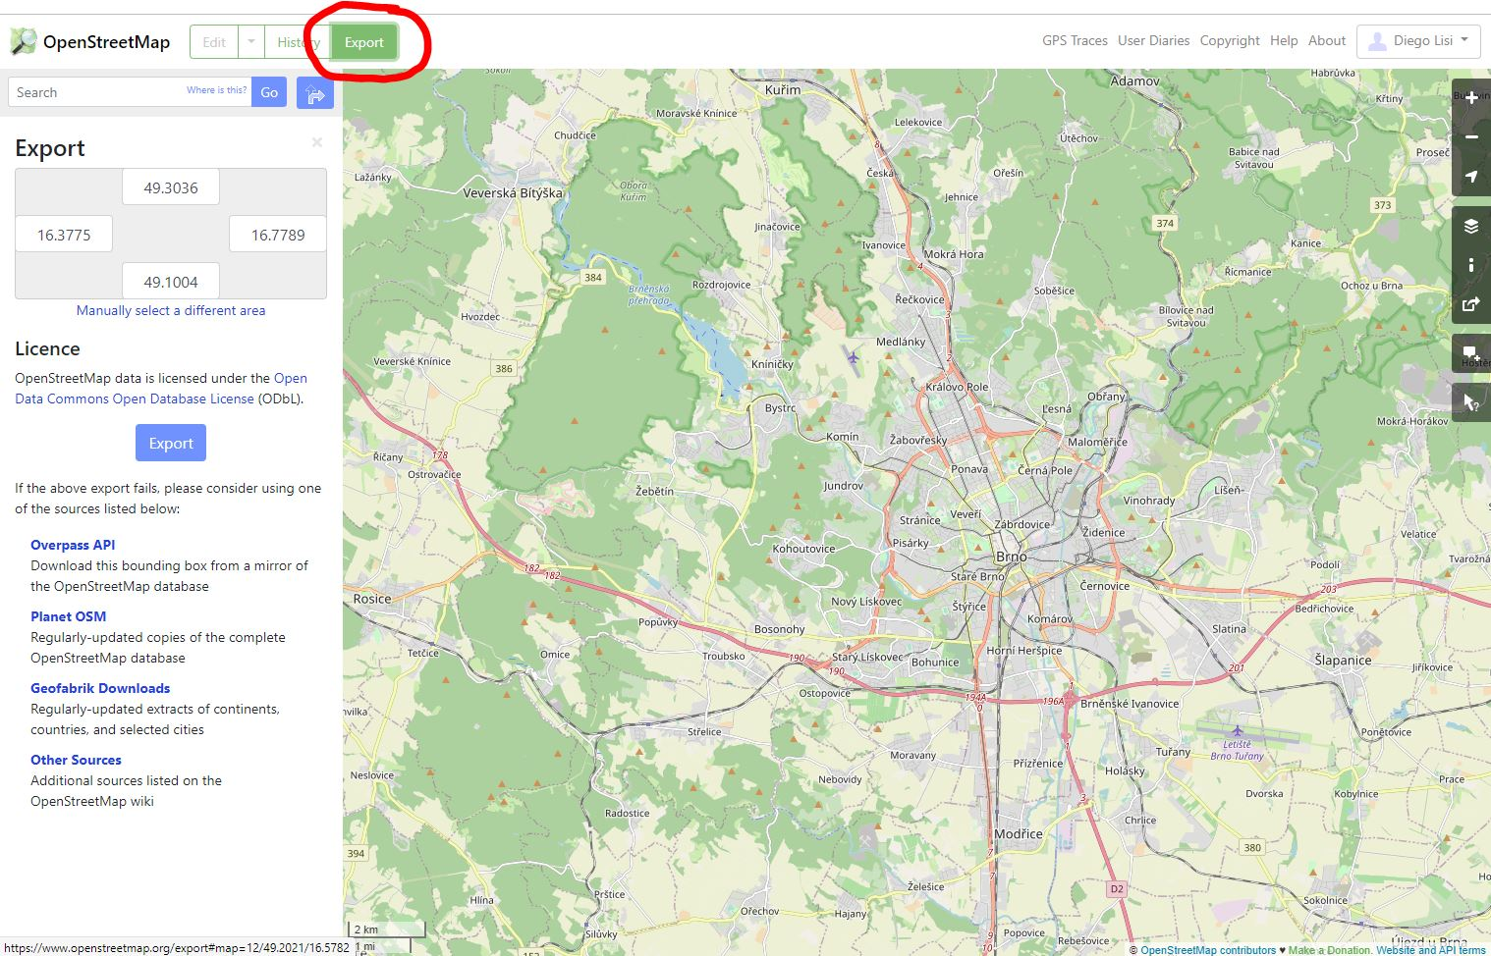
2. Then click on the “manually select a different area” as shown on the image below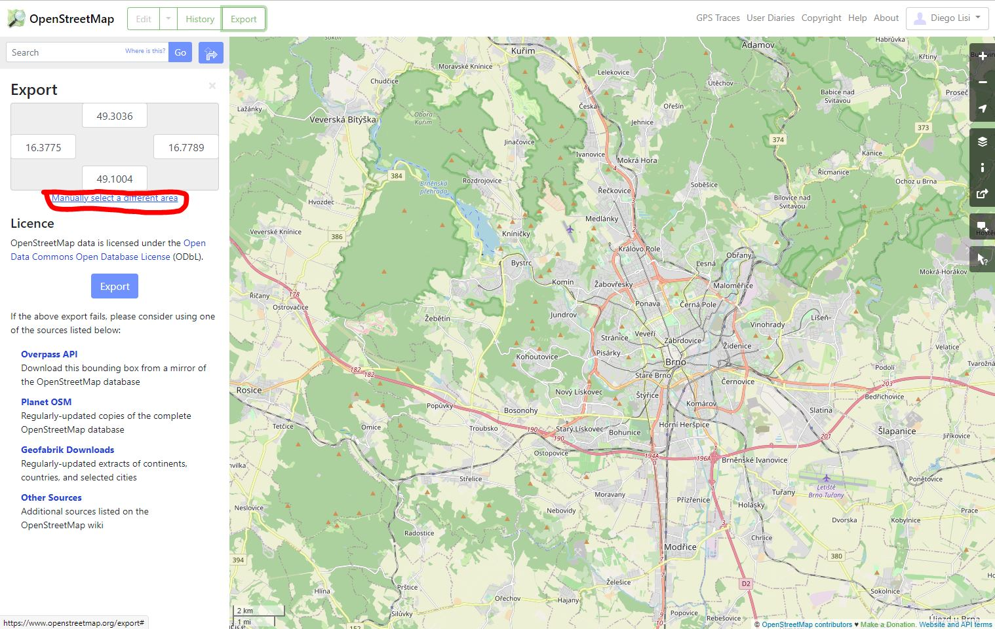
3. Drag a rectangle on the map, which covers your area of interest (the area you choose must respect the constraints defined in the “PBF File” section of this guide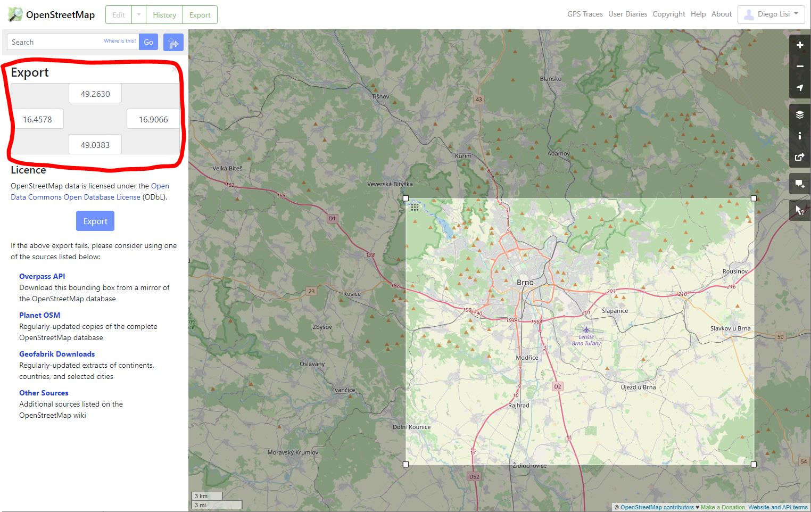

In the area shown inside the red line, you should now see your coordinate set, the numbers showed have this meaning:

* Right number: **MinX** coordinate value
* Bottom Number: **MinY** coordinate value
* Right number: **MaxX** coordinate value
* Top Number **MaxY** coordinate value

So basically (MinX,MinY),(MaxX,MaxY) identifies the bottom left point and the top right point of the rectangle

## Extracting the data – Local procedure (preferred)

**Prerequisites:**

* osmconvert tool

You can find download info, and documentation at the address: <https://wiki.openstreetmap.org/wiki/Osmconvert>

We suggest the 32bit version under windows, as described in the wiki

* A “bigger” PBF file from which clip the area of interest

Those bigger PBF files can be acquired at <https://download.geofabrik.de/>

**Execution:**

1. Visit the geofabrik site and navigate thorugh subregions (the links in the leftmost column of the table) until you match your nation, this to avoid you downloading a whole continent of information
2. Download you nation of interest in PBF file format (i.e Czech Republic) and save it in the same folder you have the osmconvert tool executable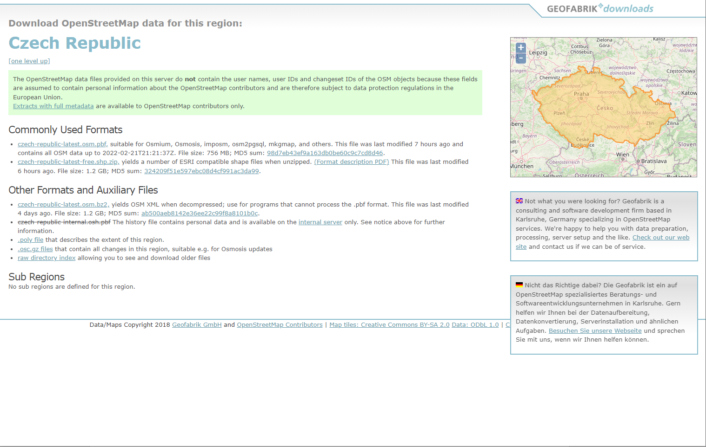

The file to download should be the first link under the “Commonly Used Format” section

1. Open a command line terminal and navigate into the folder containing the osmconvert tool and the “subregion.pbf” file (i.e in this case should be named Czech-republic-latest-osm.pbf)
2. Then issue this command, formatted as followswhere:
   1. MAP.pbf is the pbf file of the subregion you have downloaded
   2. -b=MinX,MinY,MaxX,MaxY are the points you have defined previously
   3. -o=OUTPUT_NAME.pbf the name of the output file you want to obtain
   4. –hash-memory=1500 is needed for the correct functioning of the tool, in the documentation it says that usually less is fine too (like 800)

Example:

## Extracting the data – Online procedure (alternative)

**Prerequisites:**

1. Firstly you must have a valid openstreetmap.org account (you should at this point)
2. You have to register to <https://export.hotosm.org/en/v3/> and link your hotosm account to the openstreetmap one (the site should guide you through)

**Execution:**

1. Click on the button shown below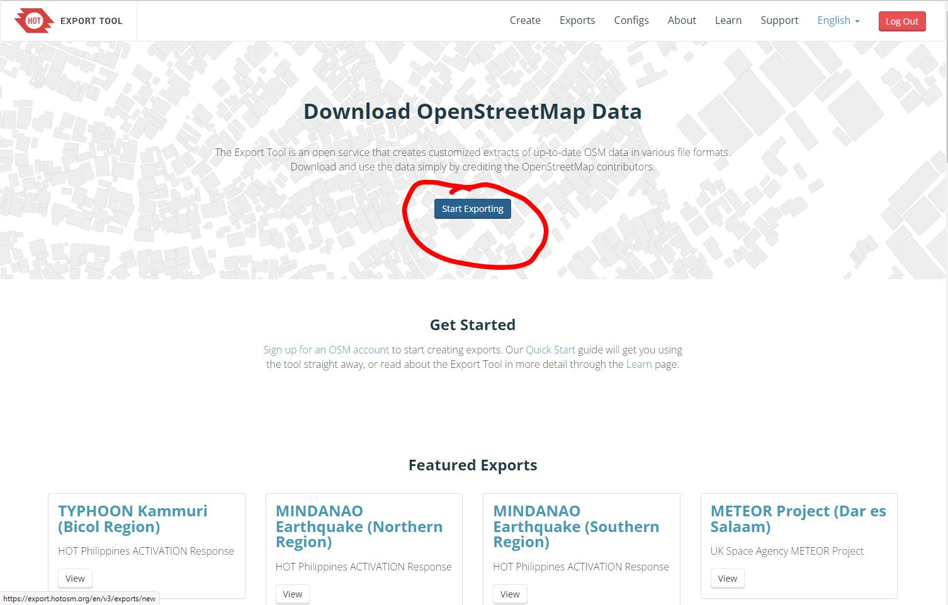
2. Fill in the information required in the form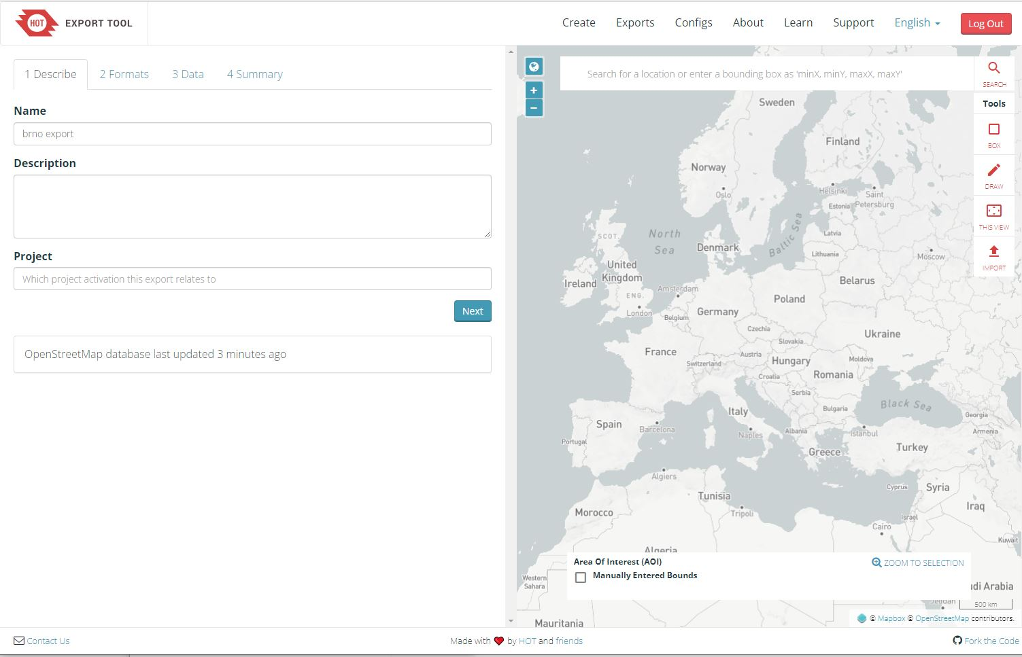
3. Chose the appropriate file format for the export procedure and hit next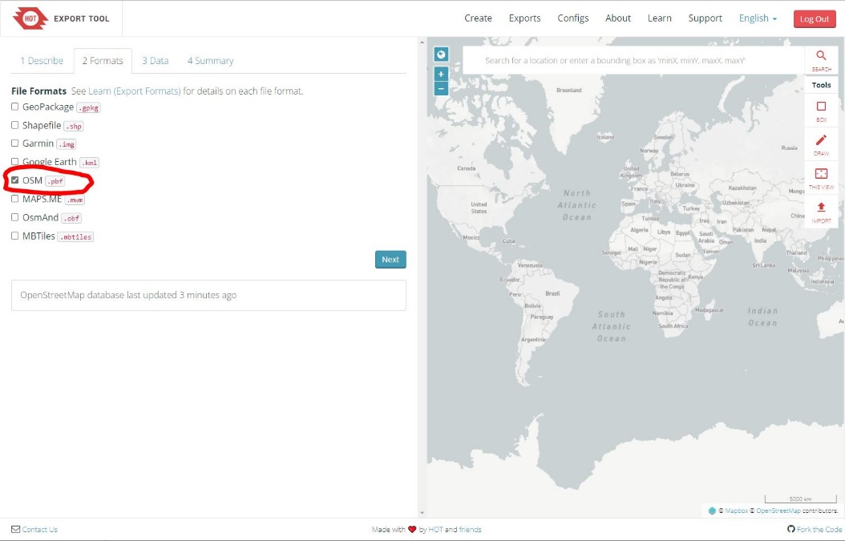
4. Chose every tag in the treetag (better be safe than sorry) and hit next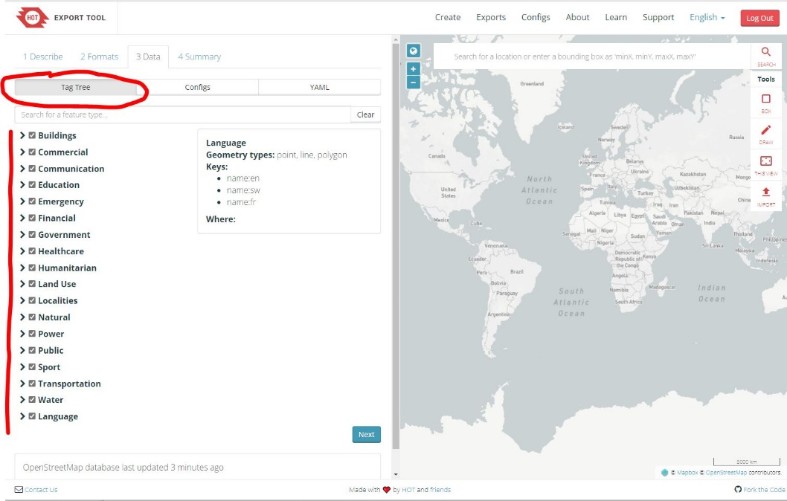
5. Fill in the coordinates you have defined before and hit the export button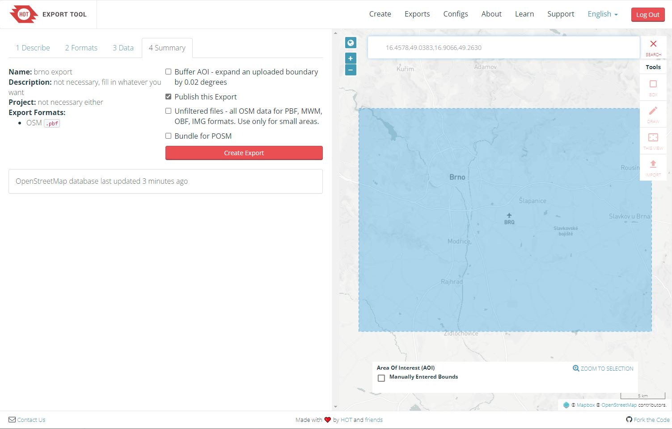
6. Wait: the operation may takes several minutes to execute, after hitting the create export button you should be redirected to a status page that will get updated when the export finish, in any case you should also receive an email (on the one you used to register to hotosm) notifying you once the export procedure has completed and the file is ready to download

# Final notes

* Online tools are usually free tools so top tier performance, should not be expected
* Once PBF files are extracted, independently of the method you chose, it would be a good practice to open them locally to briefly inspect them, there are free tool like JOSM that allows you to open and view PBF files <https://josm.openstreetmap.de/>
* Procedures depicted in this guide are not to be considered the only way to obtain the correct files, there are multiple ways of achieving the same result, you should use the one you feel more comfortable with, as long as you produce 2 files, a GeoJson and a PBF files which are coherent with respect to the other